AWS Advance Batch 1 Assignment Day 9:

Project 3:
Step1:Create two Linux instances, Use the first free Linux AMI
ss1: Instances list
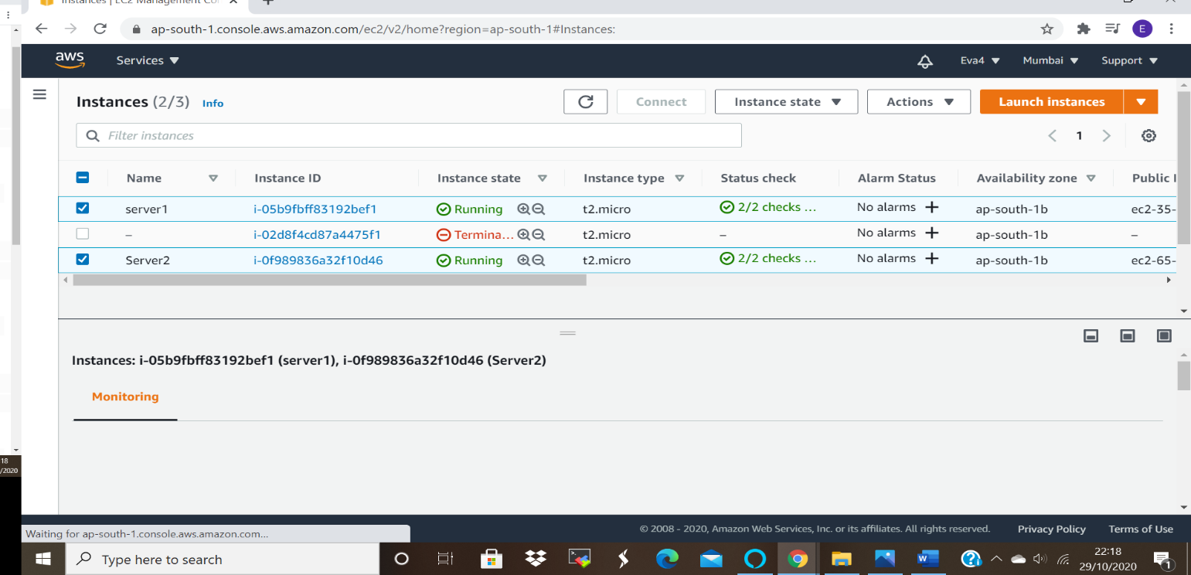

ss2: Select a instance and display instance details of server1
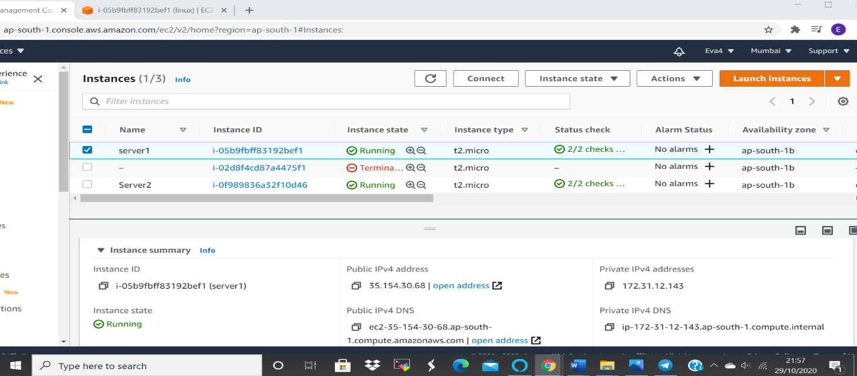

ss3: Select a instance and display instance details of server2
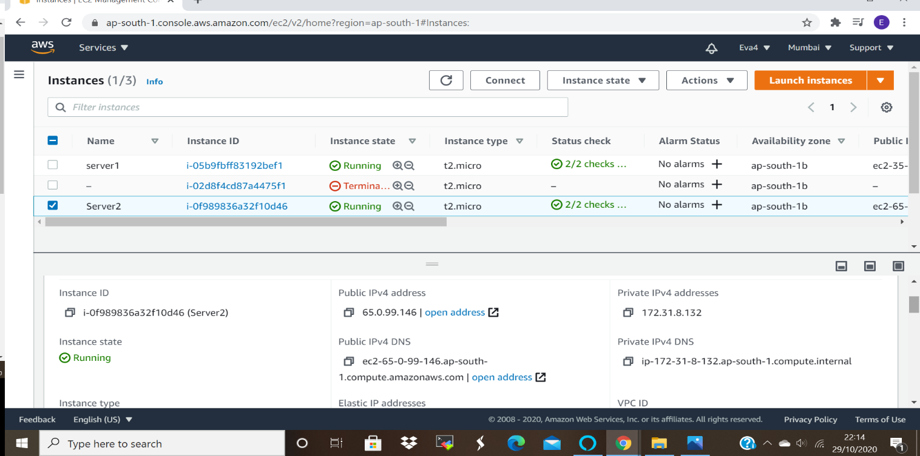

Step2: Launch both instances using Mobaxterm
Step3: Host html login webpage on both servers
(Refer video for steps)
sudo su
yum install httpd
cd /var/www/html
pwd
vi index.html
i
copy paste code
esc:wq
more index.html
service httpd start
service httpd status

ss4 :Status:Active running- black screen
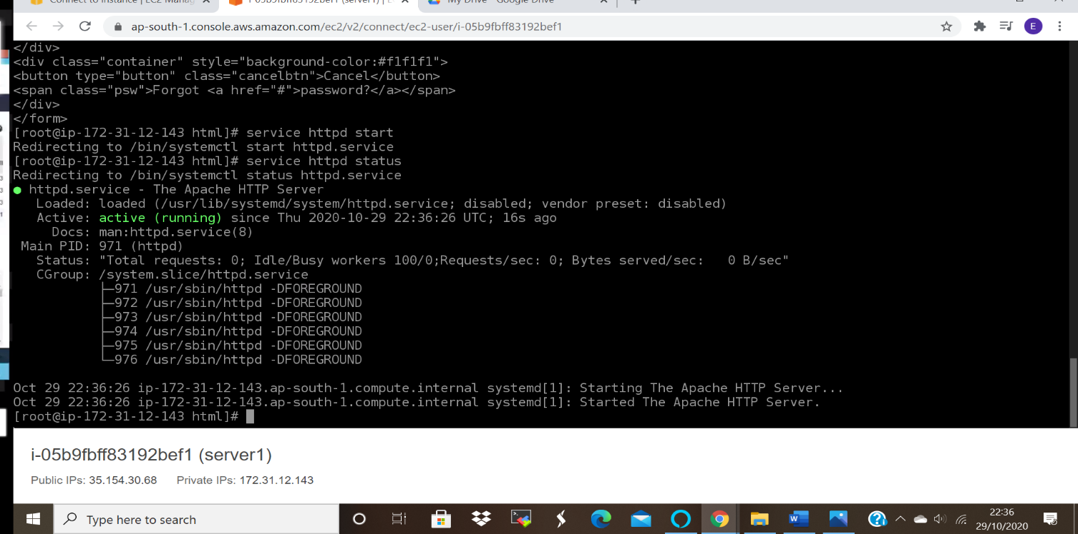

Server 2 Screen Shot:
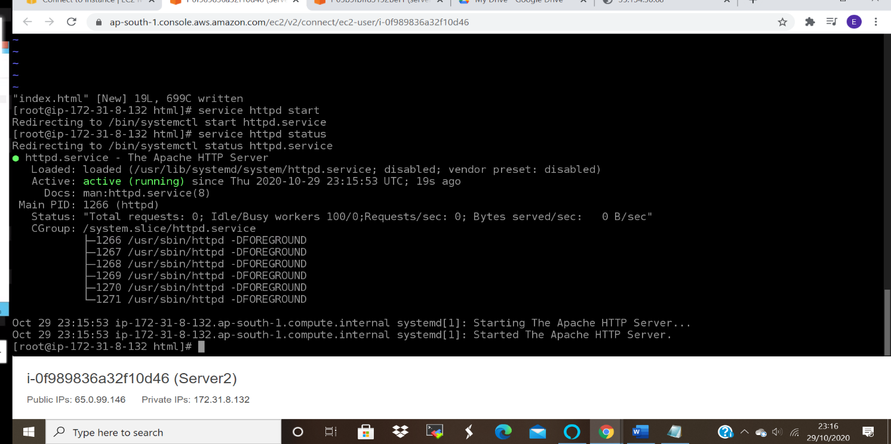

NOTE:Make change in the label of the second sever html configuration
HTML code for login page:
<form action="action_page.php" method="post">
<div class="imgcontainer">
<img src="img_avatar2.png" alt="Avatar" class="avatar">
</div>
<div class="container">
<label for="uname"><b>Username</b></label>
<input type="text" placeholder="Enter Username" name="uname" required>
<label for="psw"><b>Password</b></label>
<input type="password" placeholder="Enter Password" name="psw" required>
<button type="submit">Login</button>
<label>
<input type="checkbox" checked="checked" name="remember"> Remember me
</label>
</div>
<div class="container" style="background-color:#f1f1f1">
<button type="button" class="cancelbtn">Cancel</button>
<span class="psw">Forgot <a href="#">password? </a></span>
</div>
</form>
Step4: Check if application is deployed on both servers by copy pasting the public ip of the
servers into the browser.
Server 1: Screen shot 5
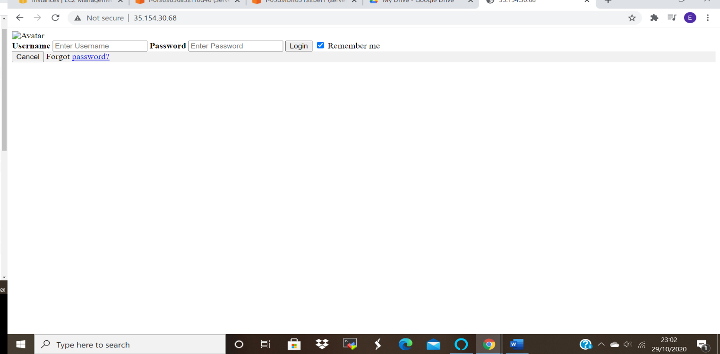

Server 2: Screenshot 6 After changing user name to userID and password to PassKey
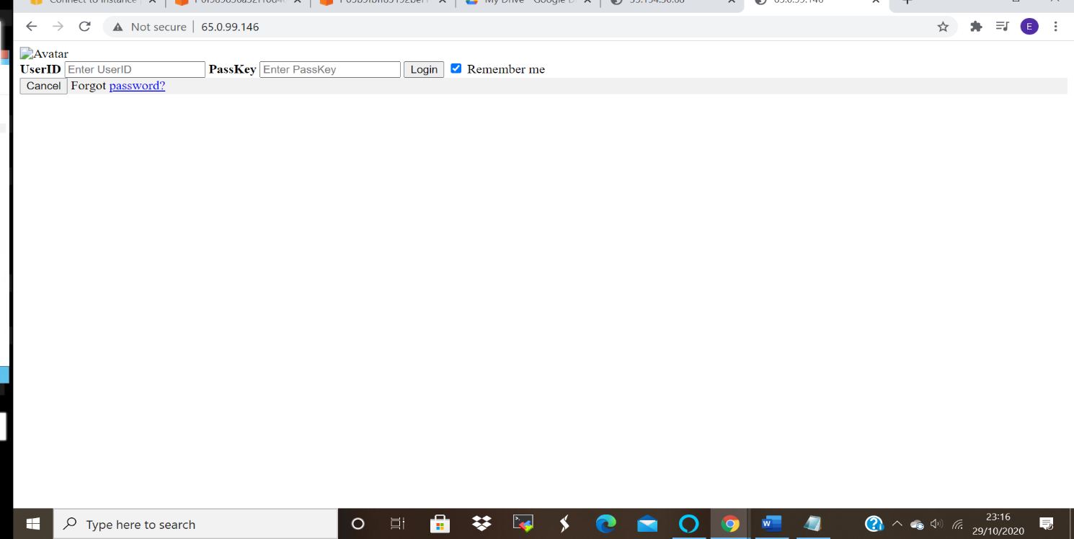

Step5: Create an application Load balancer with the above two instances as targets
ss7: Load balancer screenshot
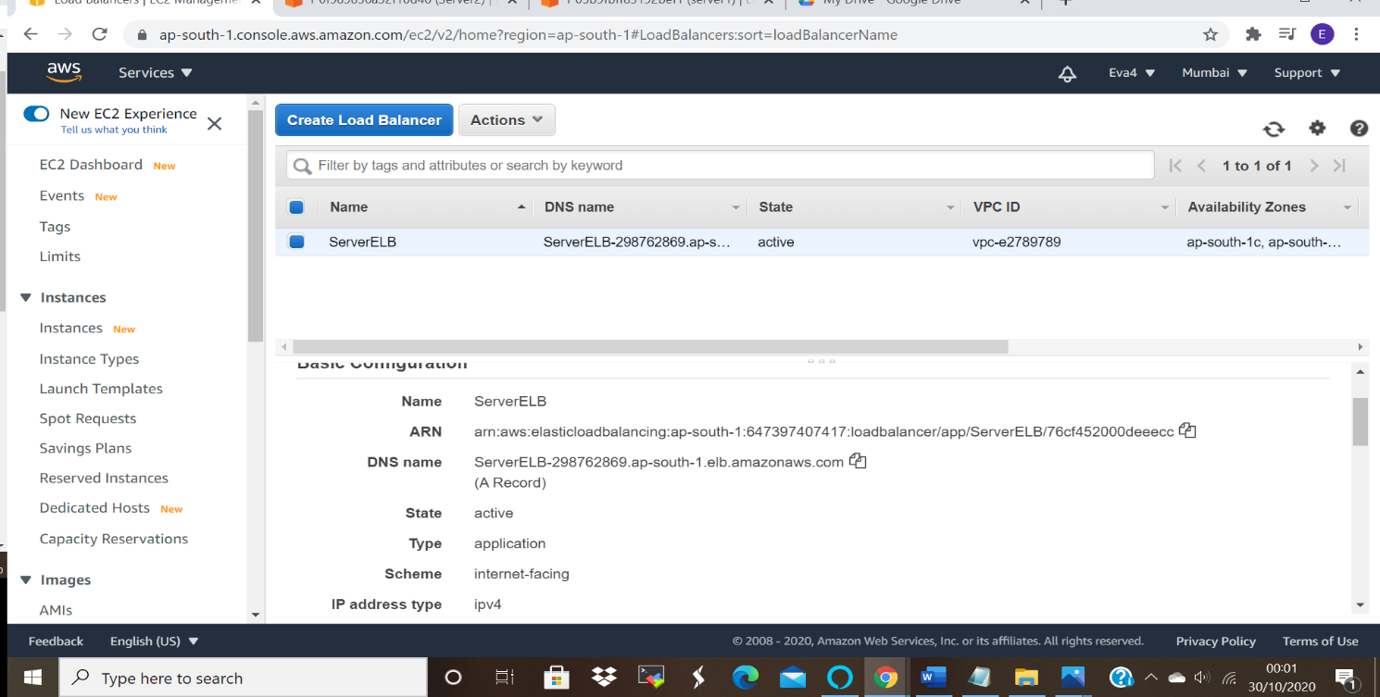

Step6: Check the functioning of ELB using the DNS of the ELB
Use the DNS
ss8: Reply from server1
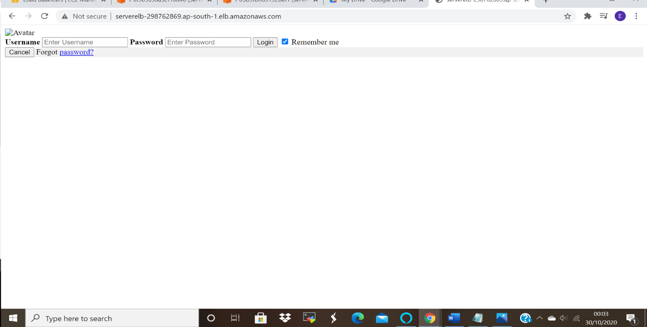

ss9: Reply from server2
